1b-2 Linux File Permissions and Group Access Control

Class Activity Overview
This lab focuses on secure file permission and user group management in Linux. Students will create users, assign group permissions, and test access control settings for different user scenarios. This is a foundational skill for managing secure multi-user systems.

Learning Objectives
- - Create users and user groups in a Linux system.
- - Configure file and directory permissions using chmod, chown, and chgrp.
- - Understand the use of group ownership to manage access.
- - Apply and test file permissions for read, write, execute scenarios.
- - Use commands such as su, whoami, and ls -l to verify permissions.
- - Demonstrate understanding of sudoers privileges and how to assign them securely.

Lab Setup and Instructions
- - Create users: `sudo adduser alice`, `sudo adduser bob`, `sudo adduser mallory`.
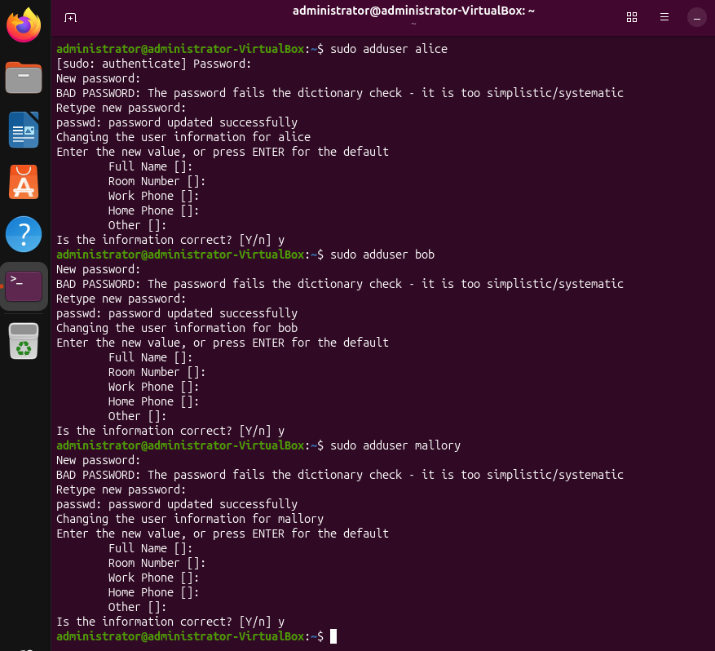
- - Create a group: `sudo groupadd sharedgroup`.
- - Create a directory: `sudo mkdir /home/shared`.
- - Create ten files inside it: `sudo touch /home/shared/file{1..10}`.
- 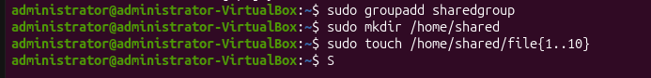
- - Change group ownership: `sudo chgrp -R sharedgroup /home/shared`.
- - Add Alice and Bob to group: `sudo usermod -aG sharedgroup alice`, `sudo usermod -aG sharedgroup bob`.
- 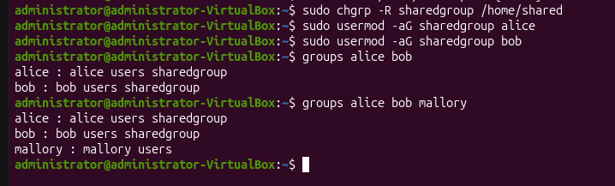
- - Set directory permissions: `sudo chmod -R 770 /home/shared`.
- - Override Bob's rights: `sudo chmod 750 /home/shared/*`.
- 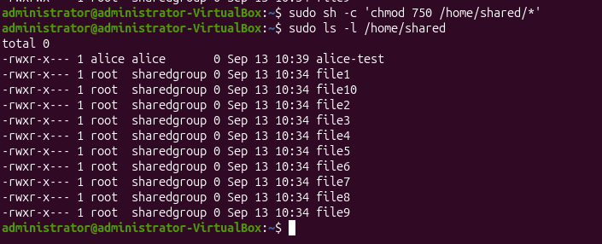
- - Remove Mallory from any group with access.
- 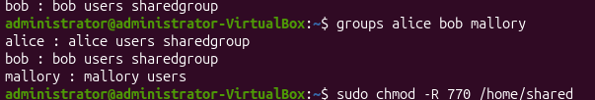
- - Switch user: `su - alice`, `su - bob`, `su - mallory`; use `whoami` and `ls -l /home/shared` to verify access.
- 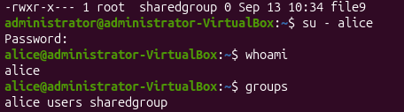
- 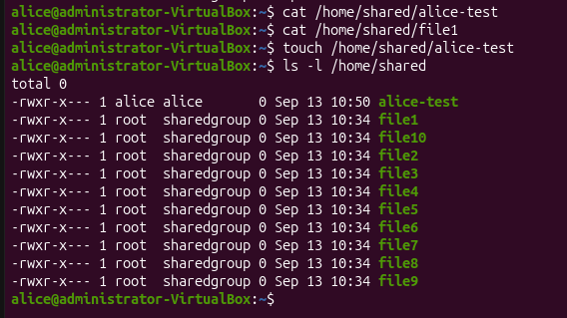
- 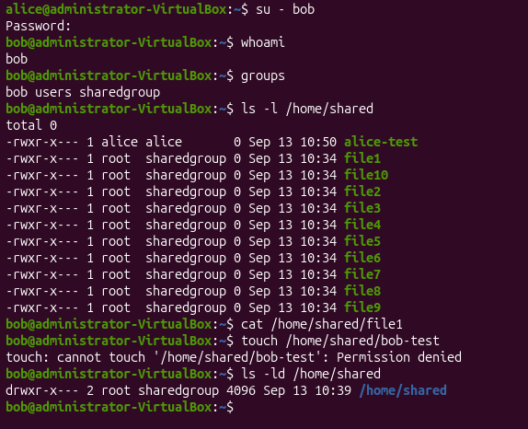
- - Document findings and permission differences per user.
- 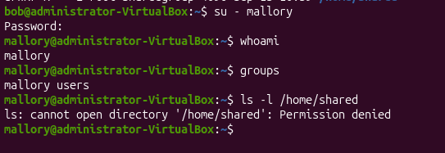

Command Reference
- - ls -l
- - groupadd, delgroup
- - adduser, deluser
- - chown, chgrp, chmod [-R]
- - su [user] -s /bin/bash
- - whoami
- - less /etc/passwd, less /etc/group
- - rm -r /home/shared

Challenge Task: Sudo Access
Grant Mallory sudo access and test its effect:
- Add user to sudo group: `sudo usermod -aG sudo mallory`
- Switch to Mallory: `su - mallory`
- Run a command with sudo: `sudo ls /root`
Discuss: How does Mallory’s access change? What are the implications of sudo privileges?

Clean-up Task
Recursively delete all test files and folders:
- `sudo rm -r /home/shared`

Reflection Questions
- - How do Linux permissions differ from Windows ACL?
- - What’s the effect of chmod 770 vs 750?
- - What is the risk of adding users to the sudo group?
- - Why is it important to verify with `su` and `whoami`?

1. How do Linux permissions differ from Windows ACL?

Linux traditionally uses three permission groups: owner, group, and others, with r, w, and x permissions. For example, chmod 770 gives full permissions to the owner and group, but none to others.

Windows ACLs are more detailed because permissions can be assigned to multiple individual users and groups with different levels of access. Linux can also support ACLs, but basic chmod permissions are simpler and less granular.

2. What’s the effect of chmod 770 vs 750?

770 means:

Owner: rwx
Group: rwx
Others: ---

So both the owner and group can read, write, and access/execute.

750 means:

Owner: rwx
Group: r-x
Others: ---

The group loses write permission. In our lab, this meant Bob could read existing files but could not edit them when they were set to 750.

For directories, write permission also affects whether a user can create or delete files inside the directory.

3. What is the risk of adding users to the sudo group?

Users in the sudo group can run commands with administrator/root privileges. This means they can install software, change system files, manage users, alter permissions, or even delete important files.

Giving unnecessary users sudo access increases the risk of accidental damage or misuse. Therefore, sudo access should only be given to trusted users who actually need administrative privileges.

4. Why is it important to verify with su and whoami?

su lets you switch to another user account so you can test what that user can actually access.

whoami confirms which user account is currently active. This is important because permission tests are only meaningful if you know which user you are testing as.

In the lab, switching between Alice, Bob, and Mallory showed that permissions behaved differently depending on group membership and file permissions.

🔐 Activity: Linux File Permissions and Group-Based Access
📘 Objective
Demonstrate understanding of Linux file permission schemes by creating users and groups, assigning proper access rights to directories and files, and validating access control using real users and the su, chmod, and chown toolset.

📦 Deliverables
# | Deliverable | Description
✅ 1 | Three Users Created | Output showing creation of alice, bob, and mallory using adduser, verified using less /etc/passwd.
✅ 2 | Group Created and Configured | groupadd sharedgroup (or similar), with alice and bob added to group via adduser [user] [group]. Verified via less /etc/group.
✅ 3 | 'shared' Directory Created in /home/ | Screenshot or command output confirming:  • mkdir /home/shared  • Ownership and group updated via chown, chgrp.
✅ 4 | Ten Files Created in 'shared' Folder | Output of touch commands or ls -l /home/shared/ showing 10 files (e.g. file1.txt to file10.txt).
✅ 5 | Permissions Assigned Properly | Screenshot of ls -l /home/shared/ showing file permissions:  • alice: rwx  • bob: r-x  • mallory: no access
✅ 6 | Access Verified as Each User | Output of:  • su - alice, whoami, file access tested (read/write/execute)  • Same for bob and mallory (showing restricted access).
✅ 7 | Use of chmod/chown/chgrp -R | Terminal output confirming use of recursive flag:  • chmod -R, chown -R, chgrp -R applied to directory and files
✅ 8 | Mallory Added to Sudoers (Challenge) | Steps taken to add mallory to sudo group:  • usermod -aG sudo mallory or adduser mallory sudo  • Verified via groups mallory
✅ 9 | Effect of Sudo Access for Mallory Tested | Evidence of Mallory using sudo to access/edit protected files or directories (e.g., /etc, files not owned by her).
✅ 10 | Folder Clean-Up Performed | Command used: rm -r /home/shared  • Screenshot or output confirming deletion of shared directory and its contents.

📝 Optional Reflection Prompts
You may also include a paragraph addressing:
- Why group permissions are more scalable than user-by-user permissions.
- The security implications of adding a user to the sudo group.
- Difference between symbolic (chmod u+rwx) and numeric (chmod 750) permission settings.

📝 Suggested Submission Format:
- .zip file containing:
  - Terminal screenshots or saved command outputs (.txt)
  - Screenshot of permissions (ls -l) before and after chmod
  - Reflection (optional) in .docx or .md format

